
Company
Logotype

Cone Beam Computed Tomography- Report



Porur Dental X-rays & CBCT

Patient Name : Miss. Kiruthika | Date of Report : 17.03.2024
Age/ Gender : 14 years/ Female | Region of Interest : CBCT Mandible
Referring doctor: Dr. A. Thara | Indication : Impacted teeth
Clinical Notes: Nil
PATIENT INFORMATION

CBCT Mandible provided
CBCT – IMAGE DETAILS

RADIOGRAPHIC INTERPRETATION

- No of teeth present in the mandibular alveolar ridge: 17
- Deciduous teeth: 73;
- In relation to 31, 32 region, the tooth 33 appears impacted between the radicular portion of 32 and 31. This occlusal plane of this tooth appears to be in line with the middle third of the root of 32.
- Distance between the alveolar ridge and crown of 33: 5.23 mm
- Distance between the lower border of mandible and apical portion of 33: 2.67 mm

RADIOGRAPHIC IMPRESSION


- Impacted tooth: 33
- Retained Deciduous: 73

IMAGES FOR REFERENCE

RECONSTRUCTED PANORAMA VIEW
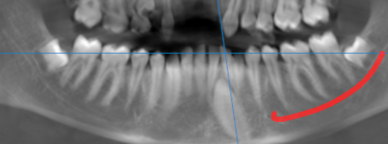

3-DIMENSIONAL VIEW

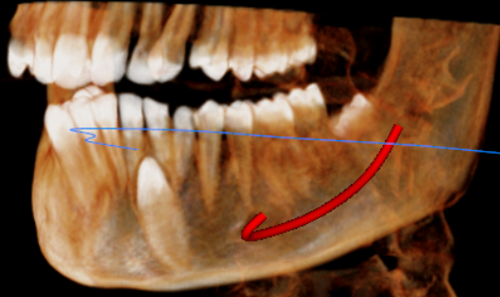
33 REGION | 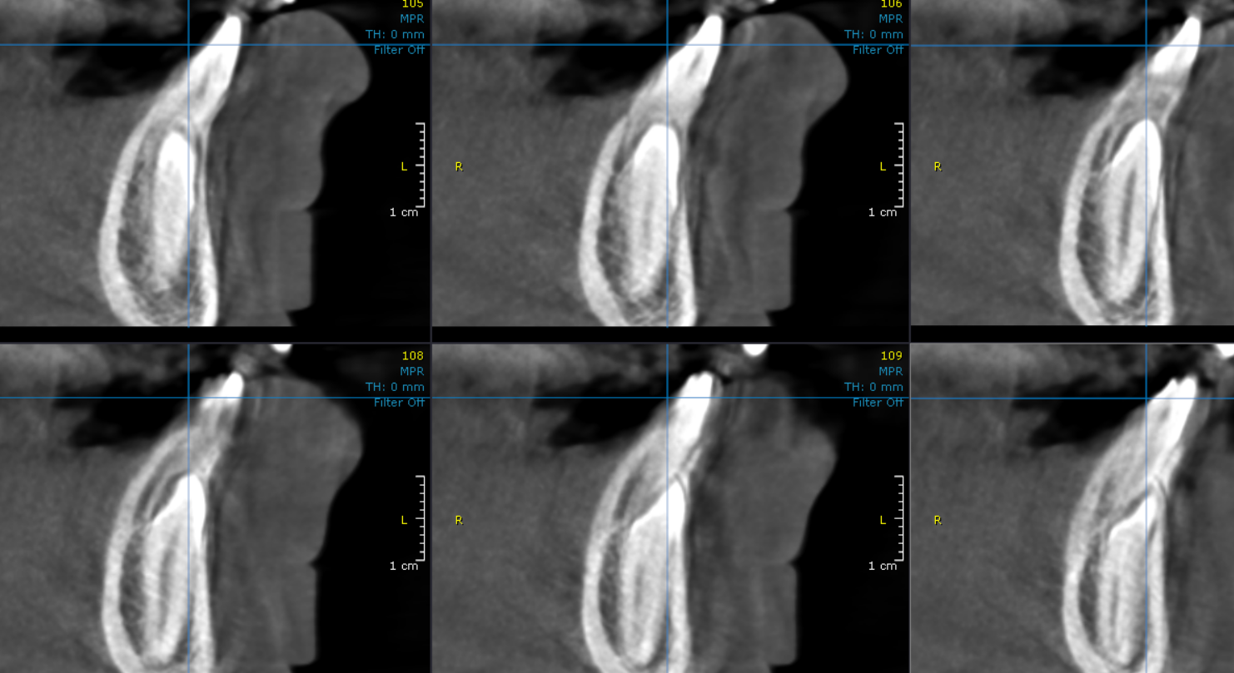

CROSS- SECTIONAL IMAGES

**** End of report ****

